Healthcare & Hospital Management System
Medallion Architecture — Implementation Report
Azure Databricks · PySpark · Delta Lake · Azure Data Lake Storage Gen2
Prepared by: Ramta
Celebal Technologies — Data Engineering Internship
Reference: Healthcare_Medallion_Architecture_PDD_v2

1. Executive Summary
This report documents the end-to-end implementation of the Healthcare & Hospital Management System Medallion Architecture pipeline, built on Azure Databricks with Azure Data Lake Storage Gen2 (ADLS Gen2) as the target platform, using PySpark, Delta Lake, and Databricks SQL, following the Project Design Document (PDD v2).
The pipeline ingests five hospital CSV data sources through a Bronze (raw) → Silver (cleansed & enriched) → Gold (business KPIs) layered architecture, using a metadata-driven ingestion framework, SHA-256 PII masking, and a centralized audit log for full pipeline traceability.
The implementation closely follows the PDD's design intent. Two categories of deviation from the original document were required and are documented transparently in this report: (1) the actual source file names and schemas differed from those specified in the PDD, and (2) four of the eight KPIs defined in the PDD could not be computed because their required source data was never defined in the PDD's data schema and was not present in the actual source files.

2. Architecture Implemented
The solution follows the standard Medallion Architecture pattern:
- Bronze Layer — raw CSV data ingested as-is from ADLS Gen2 landing zone into Delta tables, with audit/lineage metadata columns appended (_ingestion_timestamp, _source_file_name, _batch_id, _ingestion_date).
- Silver Layer — cleansed, deduplicated, validated data with cross-source joins (e.g. appointments joined to patients and doctors) and SHA-256 masking applied to PII fields.
- Gold Layer — aggregated, business-ready KPI tables built from Silver tables, serving as the analytics/reporting layer.
All data is stored in Delta Lake format, providing ACID transaction guarantees. Storage authentication uses an Azure Storage Account access key, retrieved securely at runtime from a Databricks-backed secret scope (kv-scope) rather than being hardcoded in any notebook.

3. Azure Infrastructure Provisioned
Component | Details
Azure Subscription | Azure for Students
Region | East US (selected due to student subscription region restrictions)
Resource Group | healthcare-medallion-rg
Storage Account (ADLS Gen2) | celebaldedata123 — hierarchical namespace enabled
Containers | landing, bronze, silver, gold
Databricks Workspace | celebal-databricks (Premium / Trial tier — 14-day free DBUs)
Compute Cluster | de-cluster — Single Node, DBR 17.3 (Spark 4.0.0, Scala 2.13), Standard_D4ds_v4
Secret Management | Databricks Secret Scope (kv-scope) storing the storage account access key
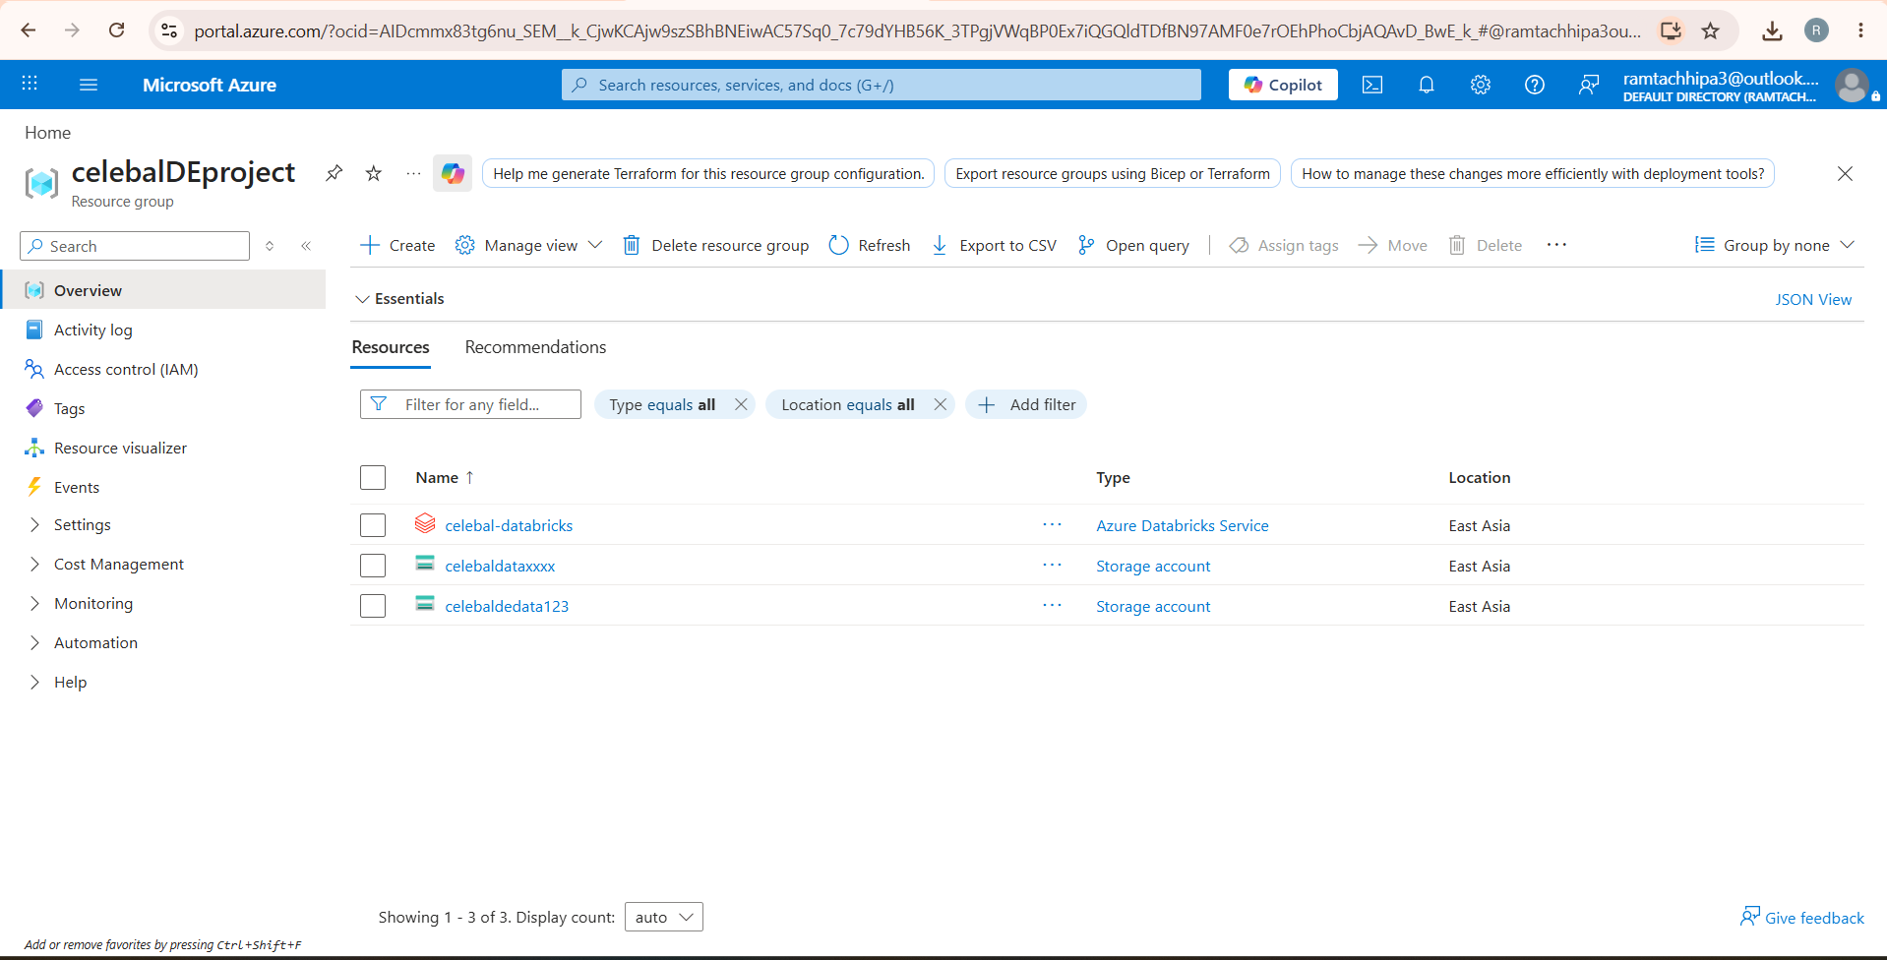
Figure 1: Resource group showing the Databricks workspace and Storage Account provisioned together.
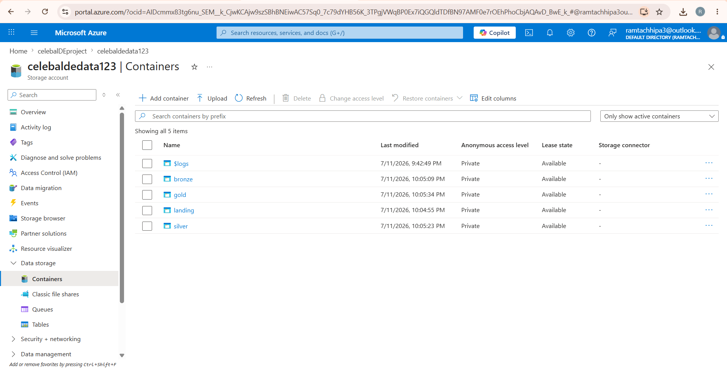
Figure 2: ADLS Gen2 storage account with the four Medallion containers — landing, bronze, silver, gold.
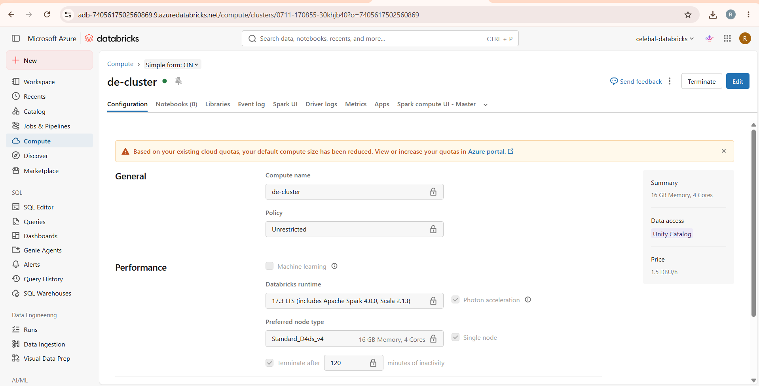
Figure 3: Databricks single-node cluster (de-cluster) in a Running state, DBR 17.3.

4. Data Source Mapping — PDD vs. Actual
The PDD specified five source files with generic healthcare naming. The actual files provided differed in name and, in two cases, in subject matter. The table below documents the mapping used throughout the implementation.
PDD Specified File | Actual File Used | Notes
patient_master.csv | patients.csv | Same subject matter; renamed
appointments.csv | appointments.csv | Matched as-is
billing_claims.csv | billing.csv | Same subject matter; renamed
lab_results.csv | Not provided | Substituted with doctors.csv
medications.csv | Not provided | Substituted with treatments.csv
Because lab_results.csv and medications.csv were not available, doctors.csv and treatments.csv were ingested in their place as the fifth and sixth data domains, both of which are natural extensions of the hospital appointment/billing model already present in the schema.

5. Notebook Implementation Summary
# | Notebook | Layer | Purpose & Outcome
00 | 00_setup_config | Setup | Created control database, metadata_config table (5 sources registered), and audit_log Delta table.
01 | 01_ingest_bronze | Bronze | Metadata-driven ingestion of all 5 sources into Delta. Rows loaded: patients 50, appointments 200, billing 200, doctors 10, treatments 200.
02 | 02_silver_patients | Silver | Deduplicated, validated patients; SHA-256 masking applied to contact_number, email, insurance_number.
03 | 03_silver_appointments | Silver | Joined to patients & doctors; added no_show_flag and cancelled_flag derived from status.
04 | 04_silver_billing | Silver | Validated positive charge amounts; standardized payment_status; joined to patients.
05 | 05_silver_doctors_treatments | Silver | Deduplicated doctors and treatments (substituted for the PDD's lab/medications notebook).
06 | 06_gold_kpis | Gold | Computed 5 Gold KPI tables from Silver data (see Section 6).
07 | 07_audit_report | Ops | Queries control.audit_log for full pipeline run history and health summary.
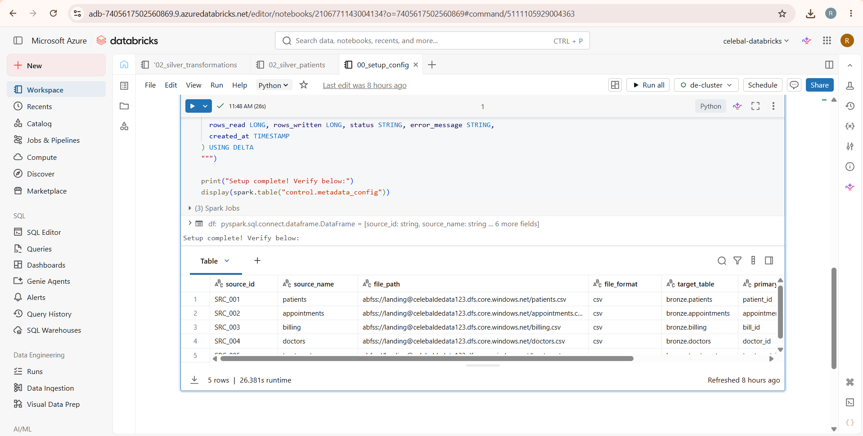
Figure 4: Notebook 00 — metadata_config table populated with all 5 registered sources.
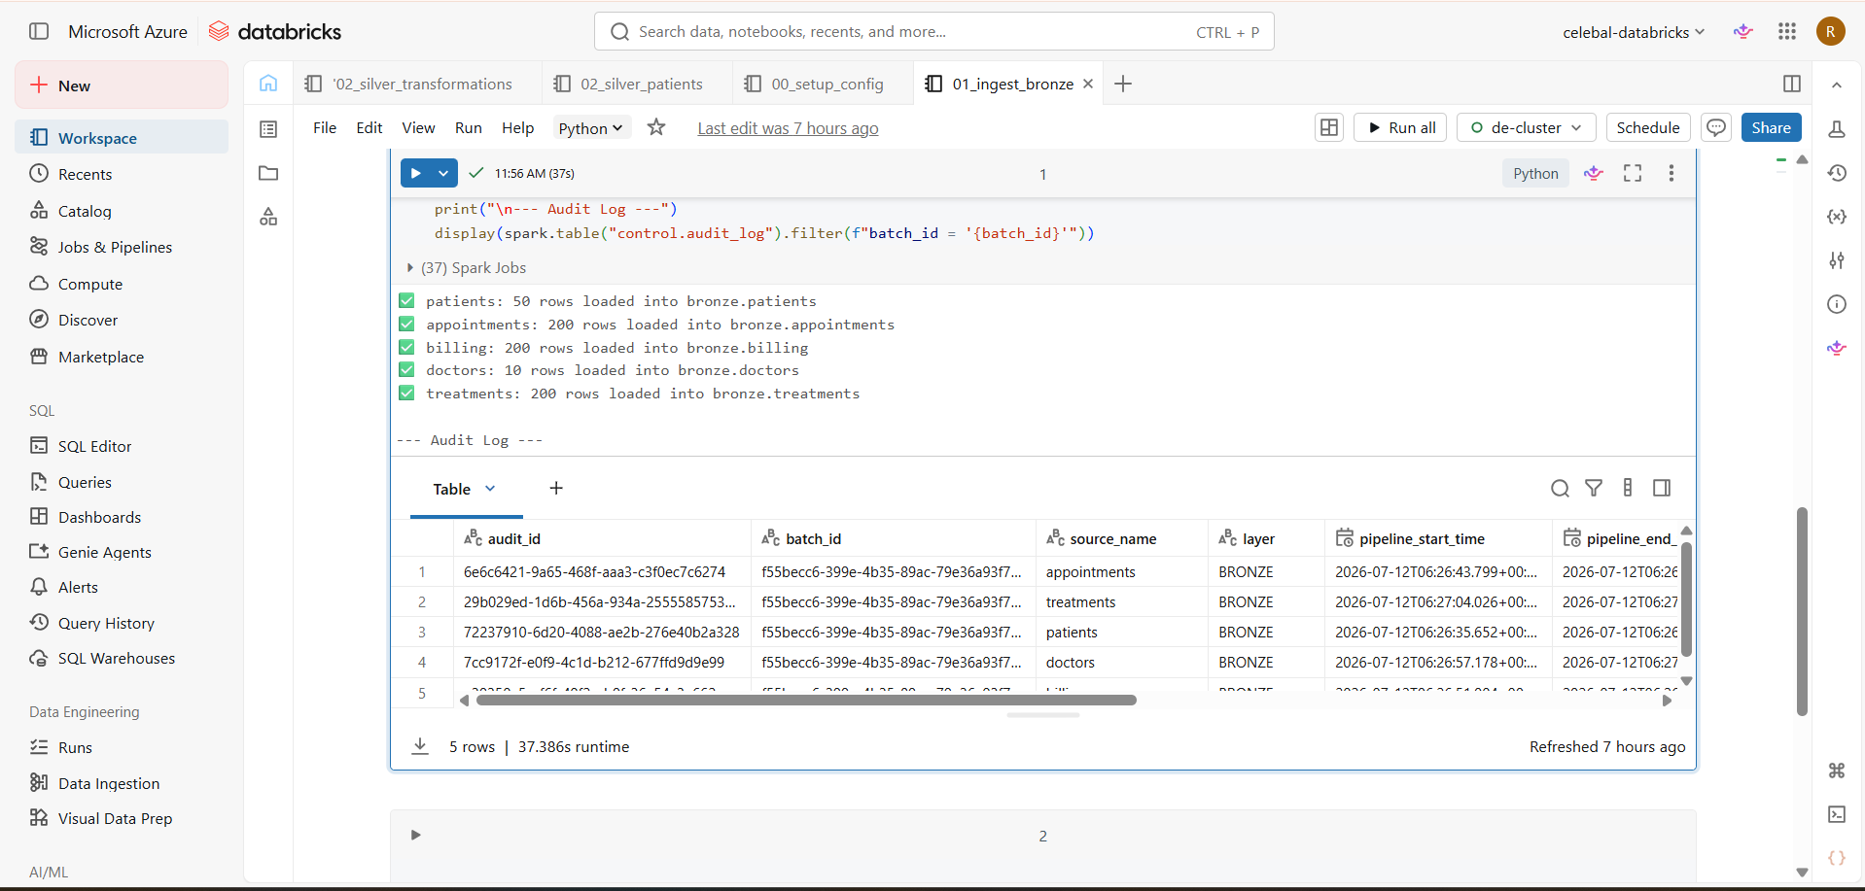
Figure 5: Notebook 01 — all 5 sources ingested into Bronze with row counts and audit log entries.
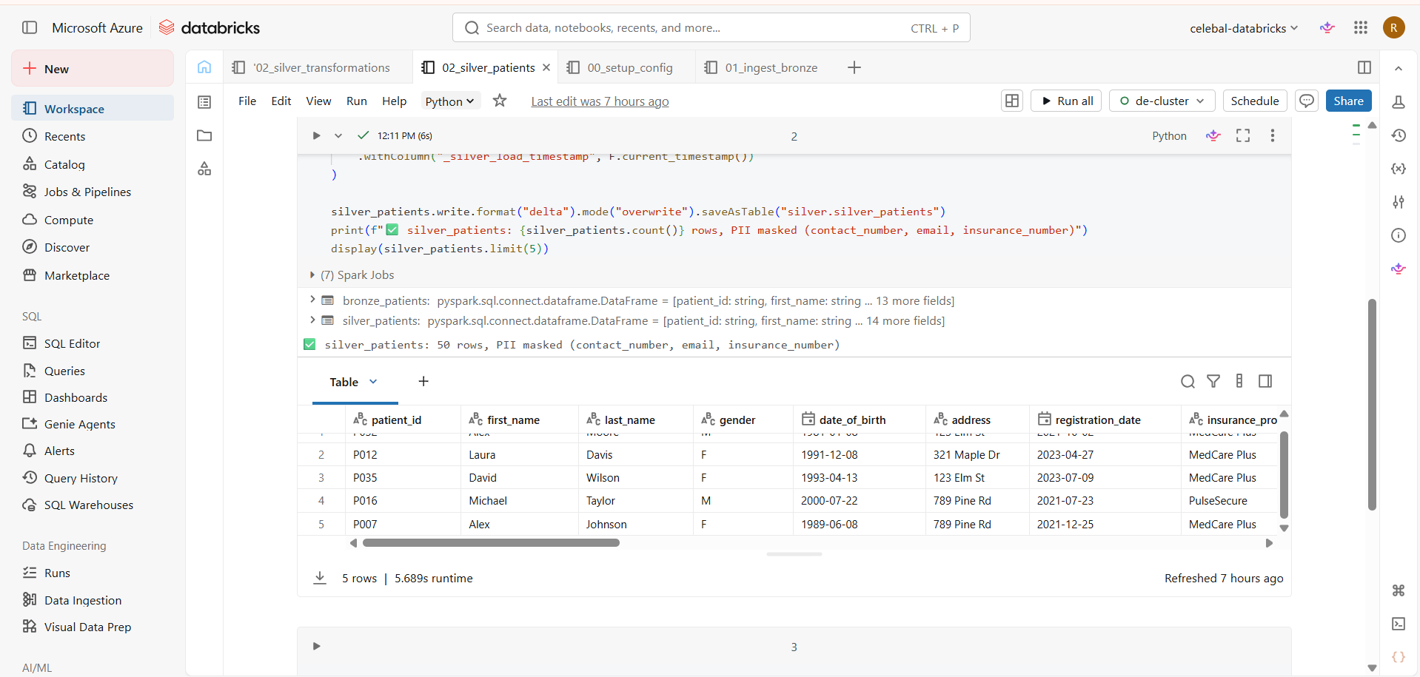
Figure 6: Notebook 02 — silver_patients with SHA-256 PII masking confirmed (contact_number, email, insurance_number).
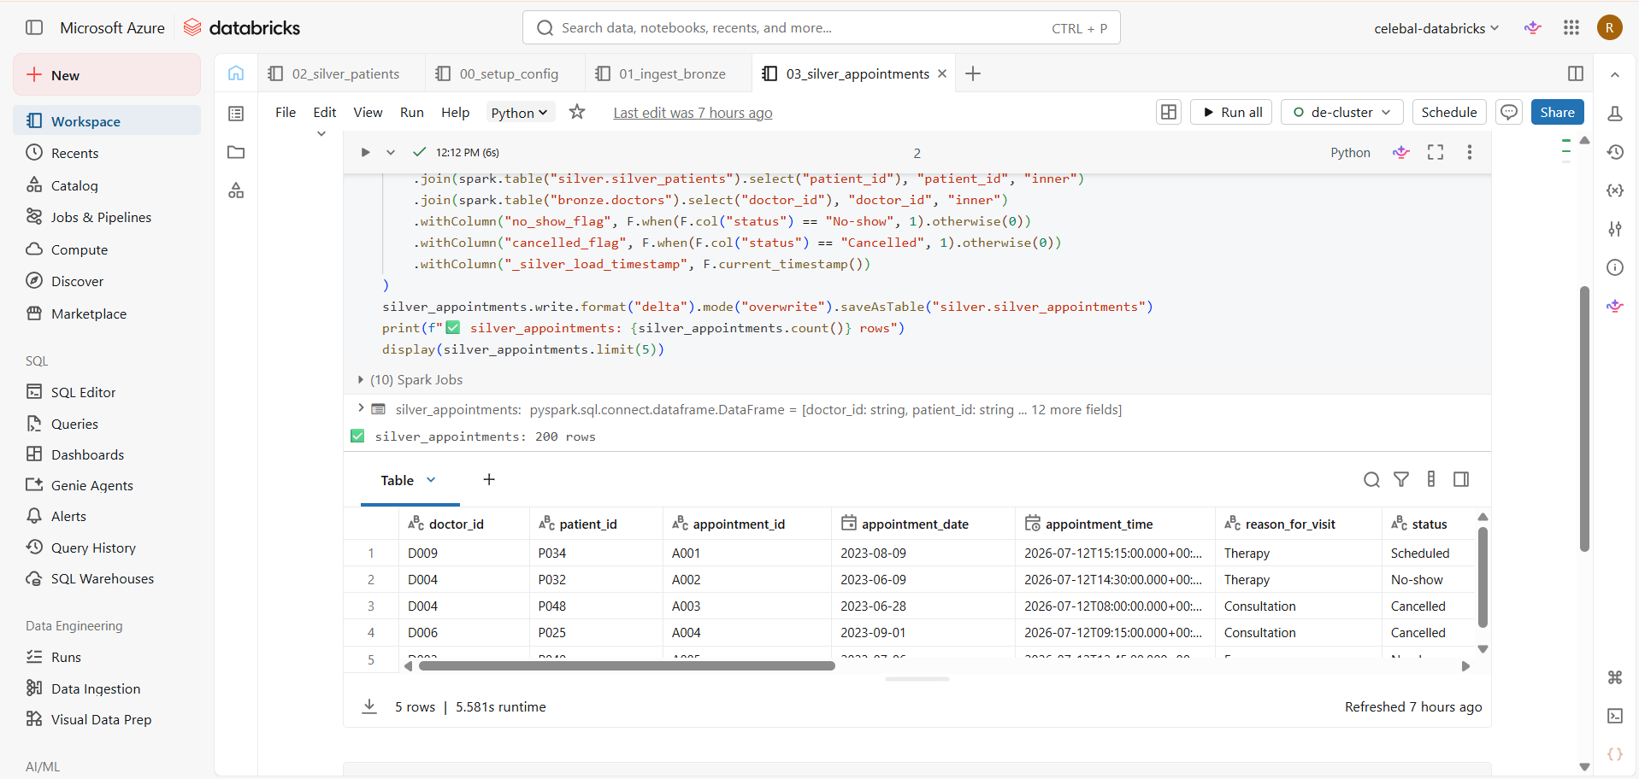
Figure 7: Notebook 03 — silver_appointments (200 rows) joined with patients and doctors.
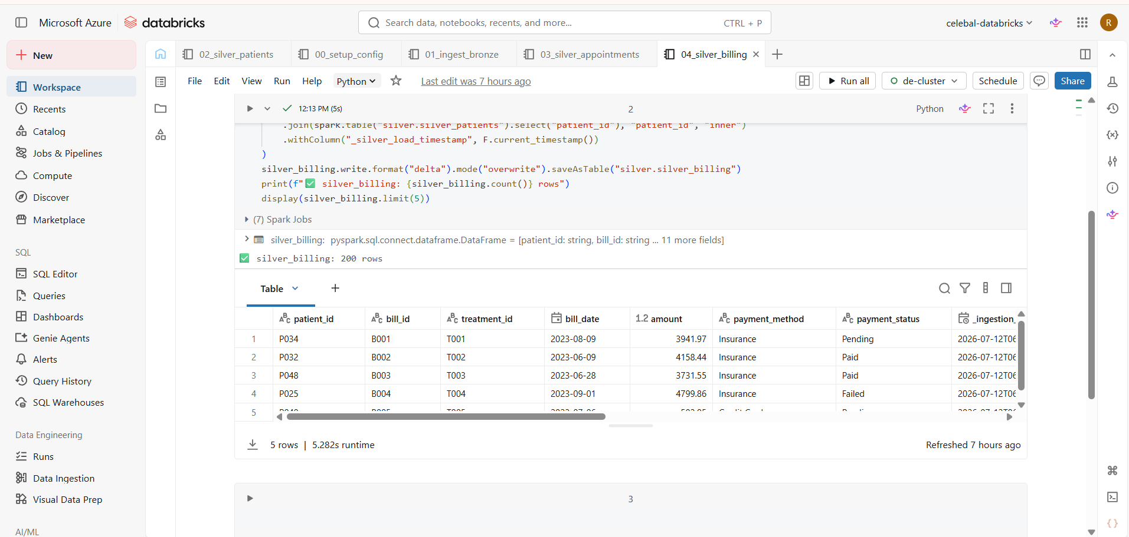
Figure 8: Notebook 04 — silver_billing (200 rows) validated and joined to patients.
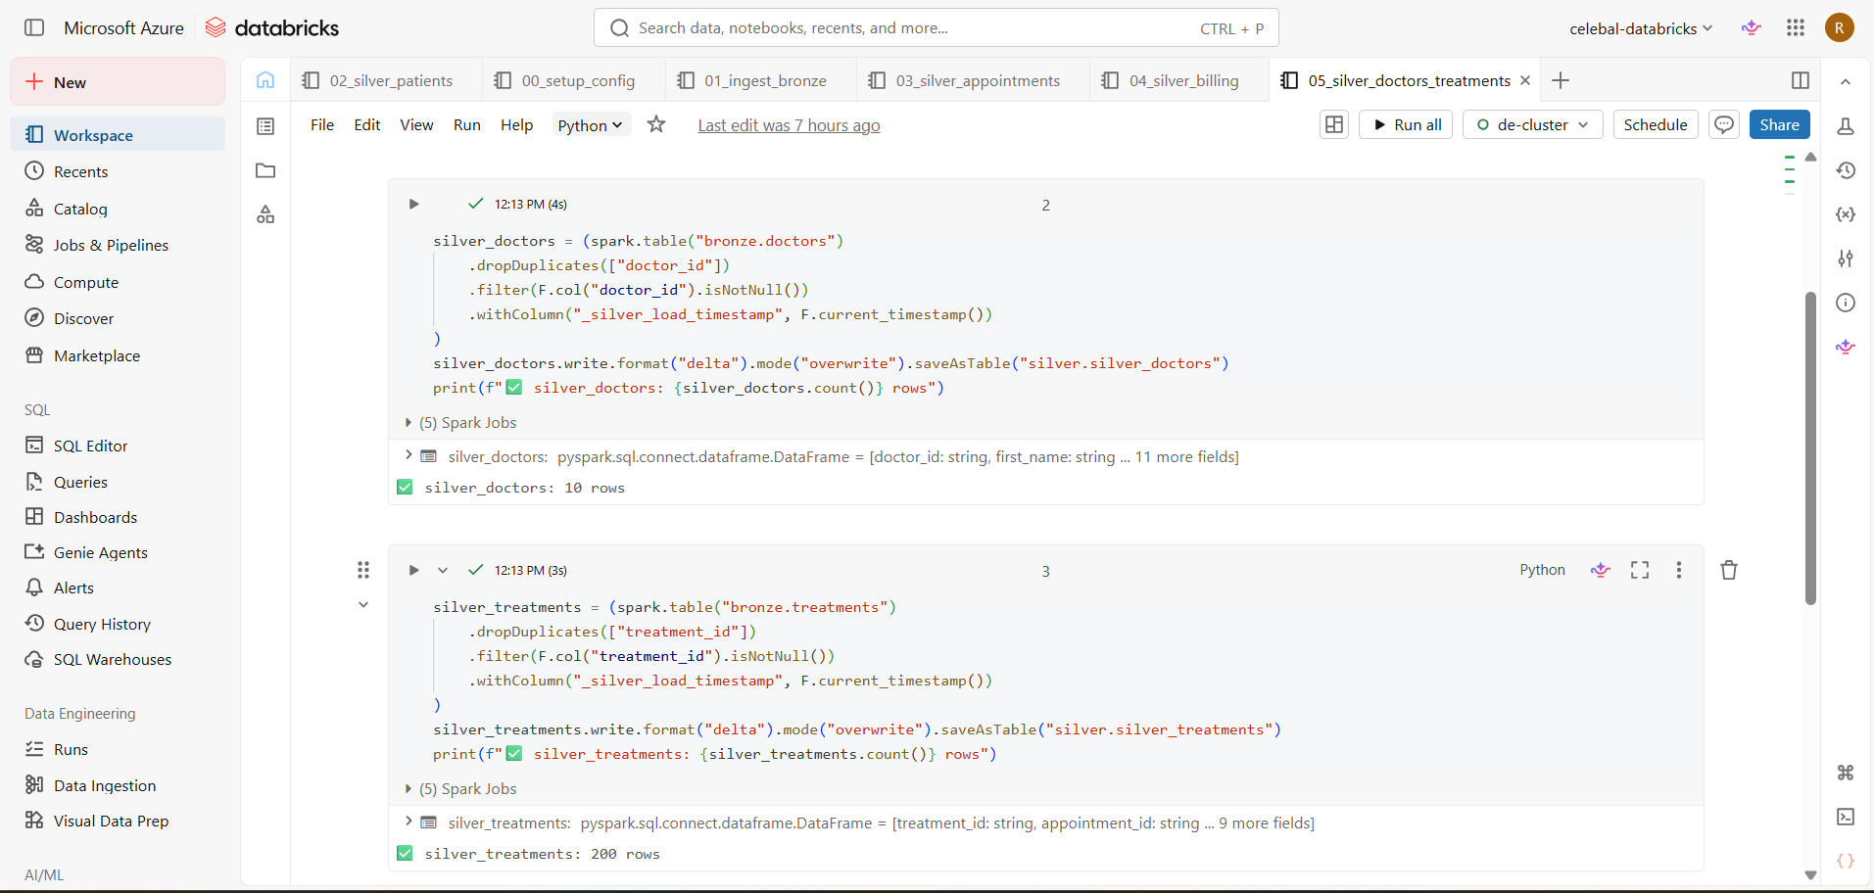
Figure 9: Notebook 05 — silver_doctors (10 rows) and silver_treatments (200 rows) cleansed.

6. Gold Layer KPIs

6.1 KPIs Implemented
The following KPIs were computed directly from Silver-layer tables and are backed entirely by data present in the actual source files:
KPI | Gold Table | Logic
Patient No-Show Rate | gold.kpi_appointment_rates | No-shows ÷ Total Appointments × 100
Appointment Cancellation Rate | gold.kpi_appointment_rates | Cancelled ÷ Total Appointments × 100
Billing Accuracy Rate | gold.kpi_billing_accuracy | Non-failed transactions ÷ Total transactions × 100
Insurance Claim Approval Rate | gold.kpi_claim_approval | Paid insurance claims ÷ Total insurance claims × 100
Revenue by Doctor Specialization | gold.kpi_revenue_by_specialization | SUM(billing amount) grouped by doctor specialization
Doctor Appointment Workload | gold.kpi_doctor_workload | Appointment count and no-show rate per doctor
Measured result (sample run): total appointments = 200, patient no-show rate = 26%. Full current values for all KPIs are available by querying the respective gold.kpi_* Delta tables in Databricks.
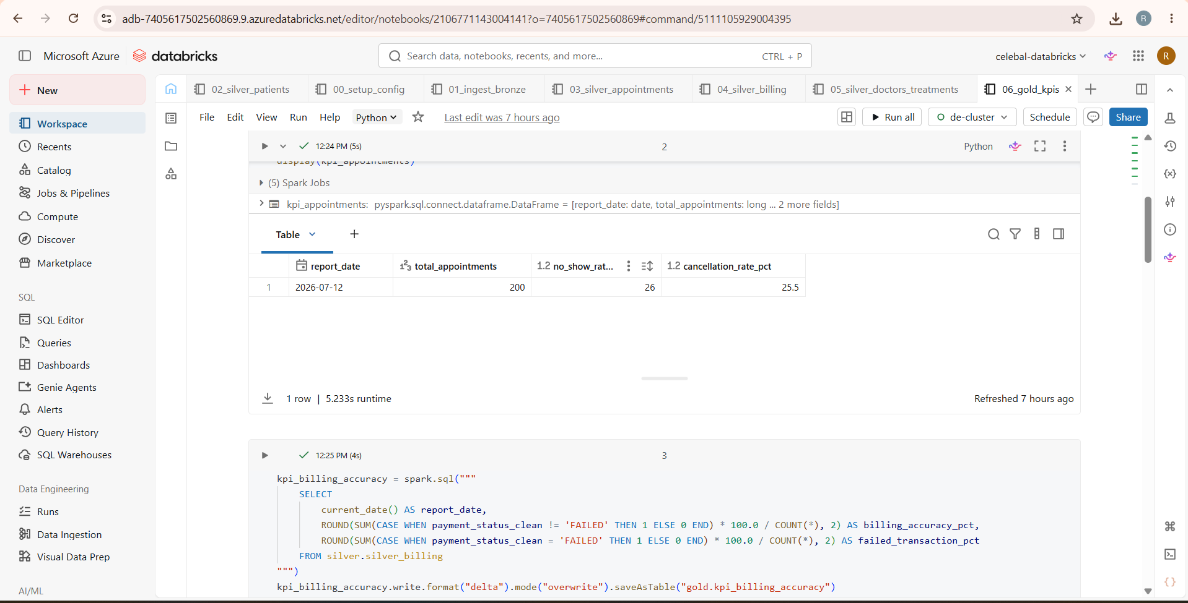
Figure 10: gold.kpi_appointment_rates — 200 appointments, 26% no-show rate, 25.5% cancellation rate.
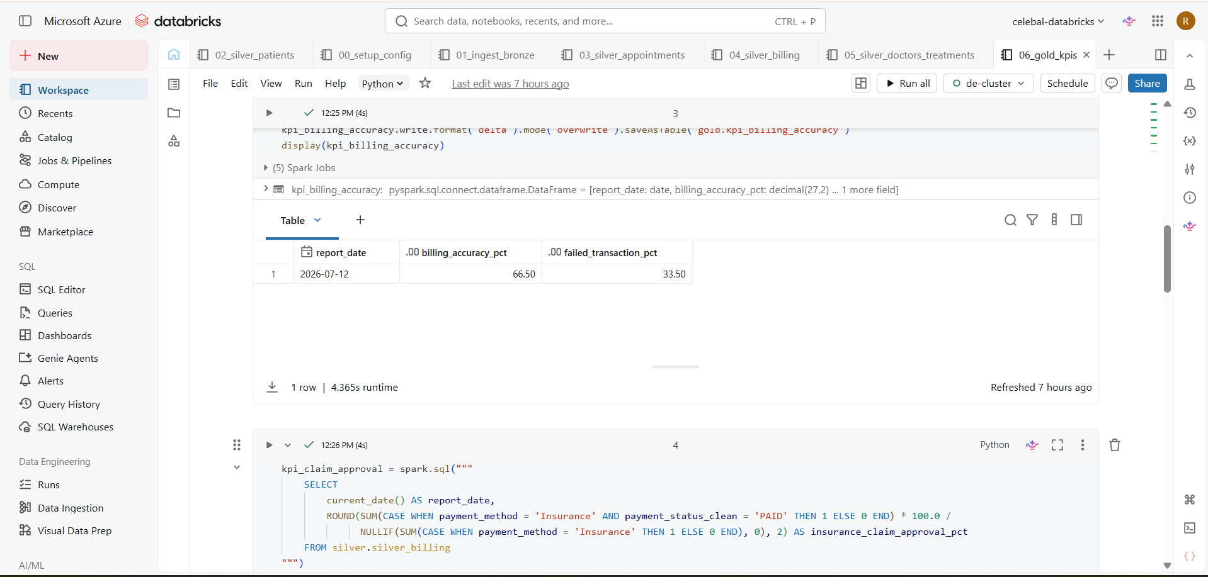
Figure 11: gold.kpi_billing_accuracy — 66.50% billing accuracy, 33.50% failed transactions.
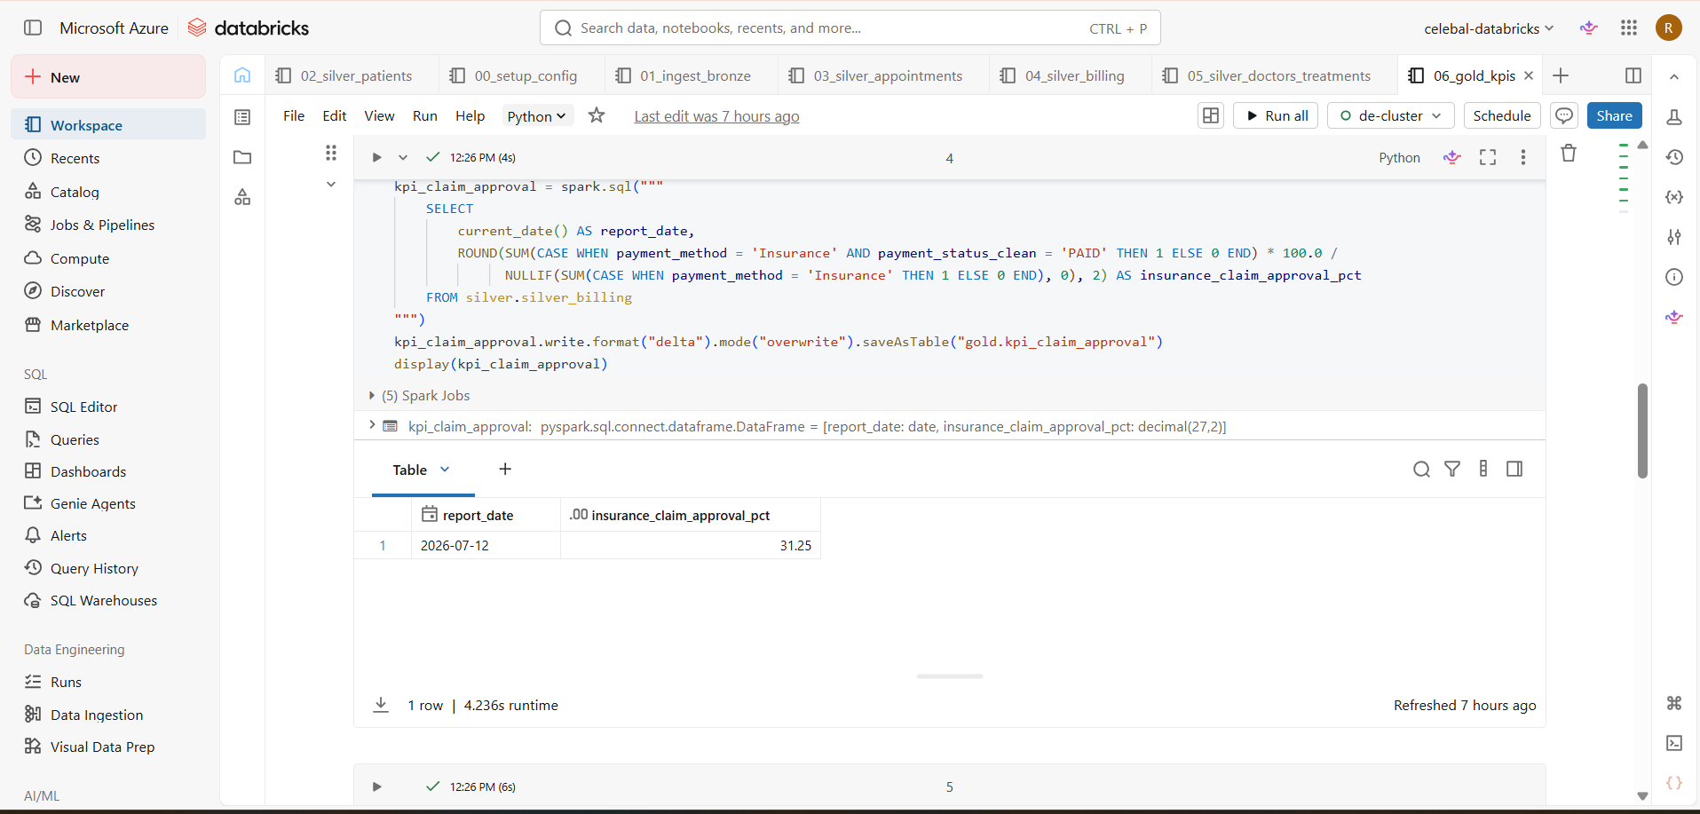
Figure 12: gold.kpi_claim_approval — 31.25% insurance claim approval rate.
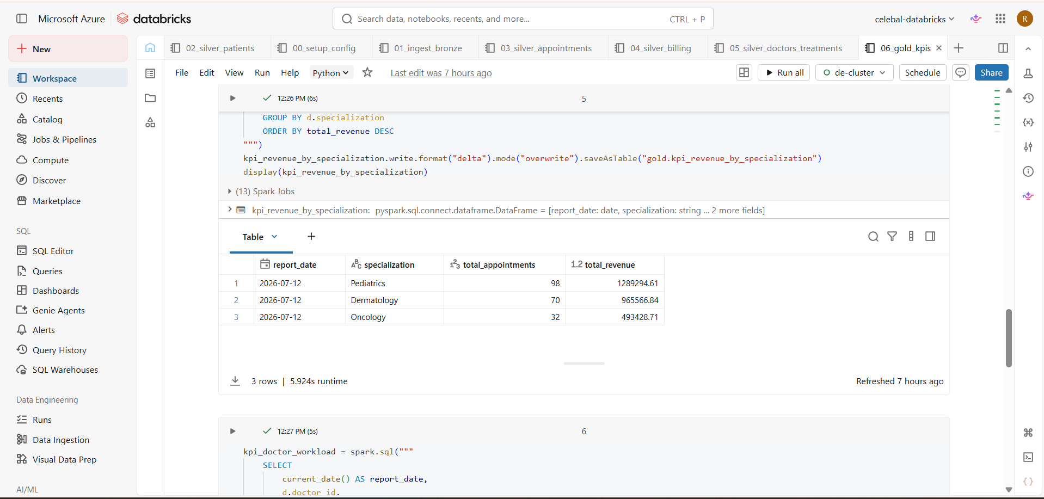
Figure 13: gold.kpi_revenue_by_specialization — Pediatrics leads with ₹12,89,294.61 in revenue across 98 appointments.
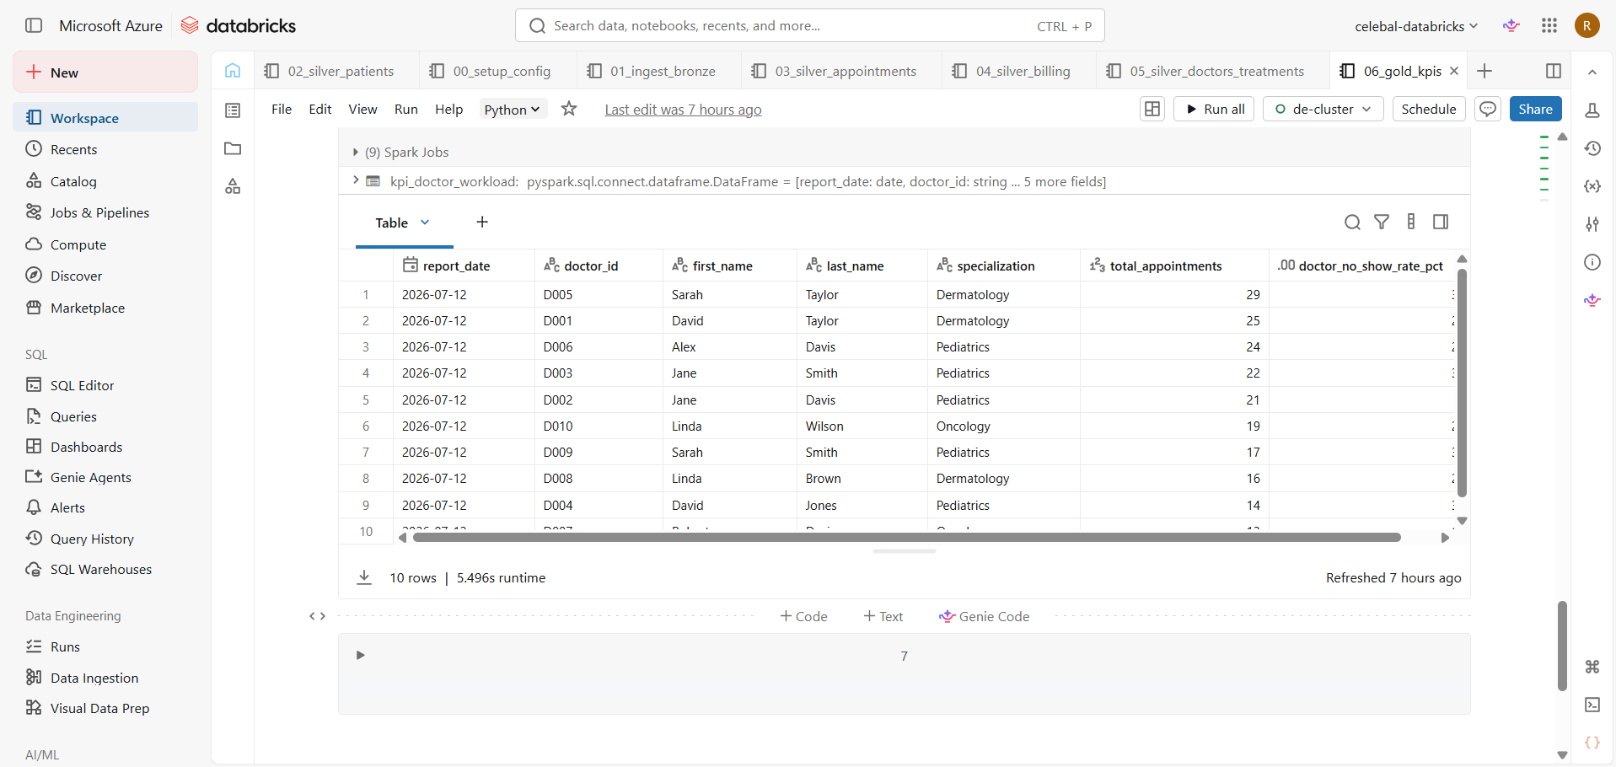
Figure 14: gold.kpi_doctor_workload — per-doctor appointment counts and no-show rates, led by Dr. Sarah Taylor (29 appointments).

6.2 KPIs Not Implemented — Data Gap Analysis
Four of the eight KPIs defined in PDD Section 9 could not be computed. This is not an implementation shortfall: the PDD's KPI formula table (Section 9, Table 10) references source columns and a silver_medications table that were never defined anywhere in the PDD's own data schema (Section 5, Table 7/8) and were not present in any of the actual source CSV files supplied for this project.
KPI (per PDD) | PDD Formula | Missing Requirement
Average Length of Stay (ALOS) | SUM(discharge − admit) / COUNT(patients) | No admit/discharge date fields exist in any source table
HCAHPS Satisfaction Score | AVG(patient_satisfaction_score) | No patient satisfaction survey data was collected
Medication Inventory Turnover | Units Dispensed / Avg Inventory Units | medications.csv was not provided; no silver_medications table exists
Patient Readmission Rate | Readmissions within 30 days / Discharges × 100 | No admission/discharge records exist to detect readmissions
Operating Cost per Patient was also affected: its PDD formula depends on silver_medications, which does not exist. Revenue per Patient/Specialization was implemented instead as the closest available substitute using billing data.

7. Data Governance, Security & HIPAA Alignment
- PII Masking: contact_number, email, and insurance_number in the patients table are hashed with SHA-256 in the Silver layer, following PDD Section 11's masking requirement.
- Credential Security: the storage account access key is never hardcoded in any notebook; it is retrieved at runtime via dbutils.secrets.get() from a Databricks secret scope (kv-scope).
- Audit Logging: every Bronze ingestion run — successful or failed — is recorded in control.audit_log with batch ID, row counts, timestamps, and error messages, supporting the PDD's HIPAA audit-trail requirement (45 CFR §164.312(b)).
- ACID Guarantees: all Bronze, Silver, and Gold tables use Delta Lake, preventing partial writes or data corruption.
- Access Control: Databricks workspace access is scoped to the project owner; Unity Catalog-based column-level RBAC (as recommended in PDD Section 11) was not configured in this student-subscription environment but is documented as a recommended next step.

8. Pipeline Audit Log — Observed Results
The audit_report notebook (07) queries control.audit_log to summarize pipeline health. A representative run showed 10 total Bronze-layer log entries, 5 marked SUCCESS and 5 marked FAILED.
The 5 failed entries correspond to an initial ingestion attempt that used the unsupported input_file_name() function under Unity Catalog; this was corrected by switching to the _metadata.file_path column, after which a subsequent run recorded 5 successful loads across all sources. This is preserved in the log intentionally, since capturing both failed and successful runs — rather than only the final clean state — is itself the behavior the PDD's audit framework is designed to demonstrate.
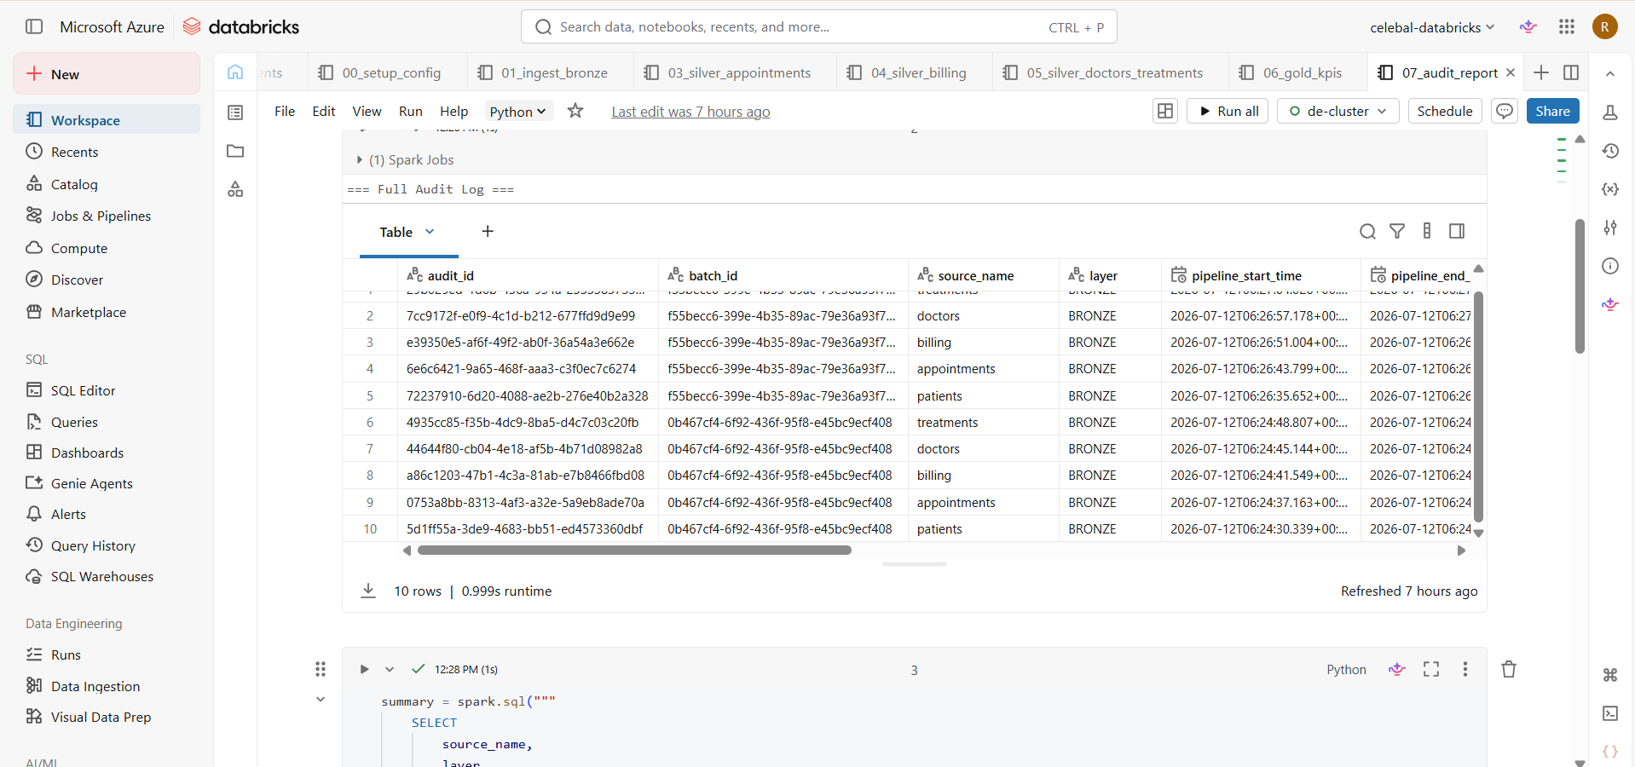
Figure 15: control.audit_log — full 10-row log across all 5 sources, spanning the failed and successful ingestion attempts.
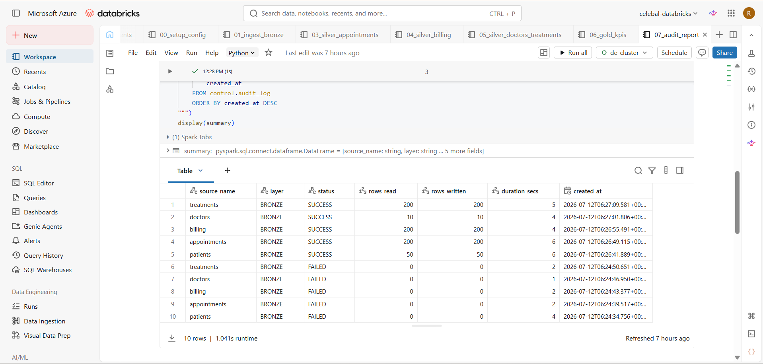
Figure 16: Per-source audit summary — 5 SUCCESS and 5 FAILED entries with row counts and durations.
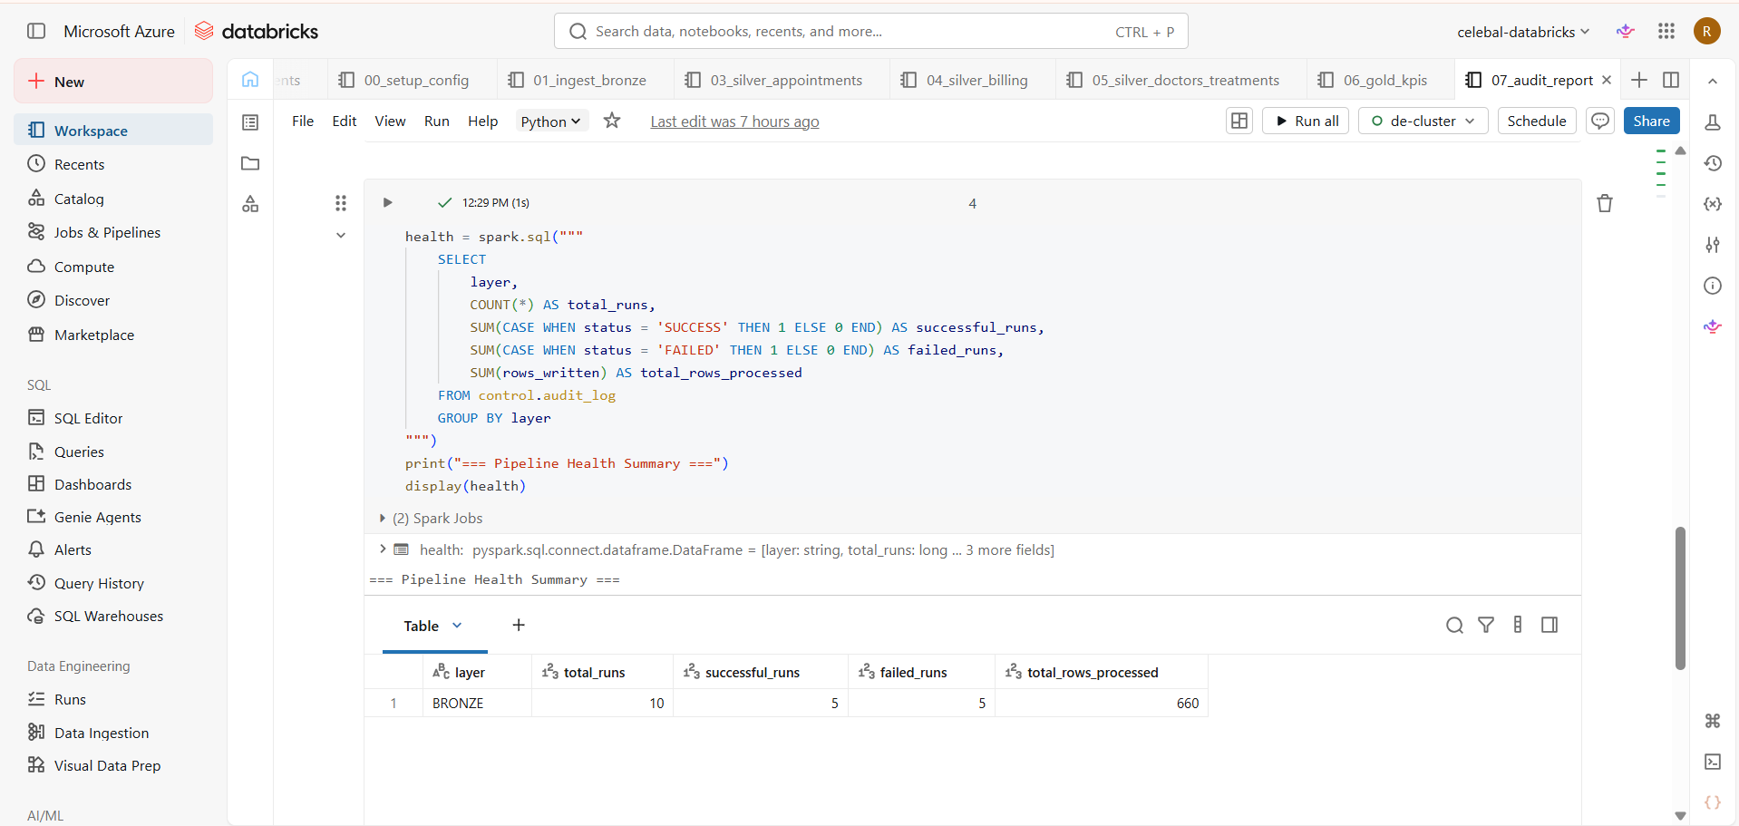
Figure 17: Pipeline Health Summary — BRONZE layer: 10 total runs, 5 successful, 5 failed, 660 total rows processed.

9. Implementation Notes & Troubleshooting Log
For transparency, the following technical issues were encountered and resolved during implementation:
- Azure for Students region restriction (RequestDisallowedByAzure) — resolved by deploying all resources to East US, an allowed region for the subscription.
- Legacy Databricks CLI (v0.18) crashed on secret configuration (Windows access violation) — resolved by installing the current official Databricks CLI (v1.7.0) via winget.
- Service Principal OAuth authentication to ADLS Gen2 failed with a proxy-selection network error inside the cluster — resolved by switching to Storage Account key-based authentication via the secret scope.
- Corrupted secret values from clipboard paste (extra characters) were diagnosed via length checks and corrected using the --string-value flag with the Databricks CLI to avoid interactive editor paste issues.
- input_file_name() is blocked under Unity Catalog; replaced with the _metadata.file_path column reference in the Bronze ingestion notebook.

10. Conclusion & Recommended Next Steps
The pipeline is fully operational end-to-end: five source files land in ADLS Gen2, flow through Bronze and Silver Delta tables with data quality handling and PII protection, and produce six business-ready Gold KPI tables, all with full audit traceability.
Recommended next steps for a production-grade extension of this work:
- Enable Unity Catalog for fine-grained, column-level RBAC as originally recommended in PDD Section 11.
- Schedule notebooks 01–07 as a Databricks Workflow with the dependency chain defined in PDD Section 8.1.
- Source or simulate admit/discharge and medication inventory data to close the four-KPI gap identified in Section 6.2.
- Build a Databricks SQL Dashboard on top of the gold.kpi_* tables for live reporting.

